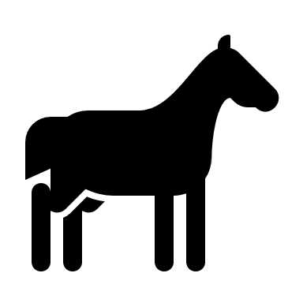 EQUINE FACILITY INSPECTION - STORM EVENT PREPARATION 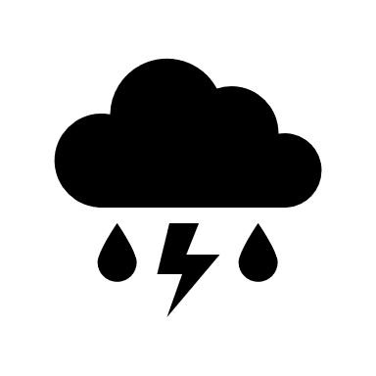
Prior to anticipated storm events, during extended storm events, and after actual storm events¹ – Perform visual inspections of production area, stormwater containment structures, closest receiving water, and manure application areas for the conditions noted below. Note any conditions or changes that could result in discharges to surface water and/or from property under the control of the Discharger. Record the date, checkmark the appropriate selection, and provide notes as needed. A copy of this form will be needed for each significant storm event.
Date of major storm event inspection: ___________________________ |  | Before Storm  (Initial or write N/A): | During Storm (Initial or write N/A): | After Storm (Initial or write N/A): | Notes
Retention Ponds/Structures (if applicable)
Inspect for berm integrity, cracking, slumping, excess vegetation, burrowing animals, and seepage.
Receiving water  Inspect the closest receiving water, upstream and downstream of all facilities, and disposal areas to monitor any change in water quality resulting from facility operations.  Report visible signs of adverse water quality impacts from any part of the facility (erosion, setback violations, animal access to surface water, waste discharges). | Upstream and downstream of all facilities and land application areas remain unchanged?  [ ] Yes [ ] No
Confinement area  Describe any conditions or changes that could result in discharges to surface water and/or from property under the control of the discharger. Note actions taken to correct any noted deficiencies. Attach additional notes as needed. *Reminder: storm water should be managed to prevent contact with manure and/or feed waste. Comingled storm water needs to be retained and managed as part of the liquid manure stream. | Pollution prevention measures* implemented and effective as specified in the facility’s Ranch Water Quality Plan?  [ ] Yes [ ] No

(¹A major storm event is defined as a storm event that results in at least 1 inch of rain per 24 hours.)
NOTE: This record must be maintained for a period of five years after it is created.
*Pollution prevention measures can include roof runoff diverted away from confined areas or berms intact and protected from erosion.
Photo monitoring sheet and checklist
Use this form to document your pre-rainy season pollution prevention measures.
Date:___________________Time:_________________Observer:_____________________
Facility Name: ___________________ Facility Address:_____________________________
Photo #:________

Did you check each of the following areas to ensure pollution prevention measures in the RWQP are implemented and effective? It is important to check all critical areas before, during large, and after storms.
- Berms? ☐ Yes ☐ No ☐ N/A (explain)_____________________________________________________________
- Closest Receiving Waters? ☐ Yes ☐ No ☐ N/A (explain)______________________________________________________________
- Confined Areas: corrals, paddocks, stalls, etc? ☐ Yes ☐ No ☐ N/A (explain)______________________________________________________________
- Are manure storage areas, feed and compost covered? ☐ Yes ☐ No ☐ N/A
(explain, if needed) _______________________________________________________
- Photo taken? ☐ Yes ☐ No
Insert Photo(s)Below: Use additional sheets if needed.
Subject Description:
Comments:

