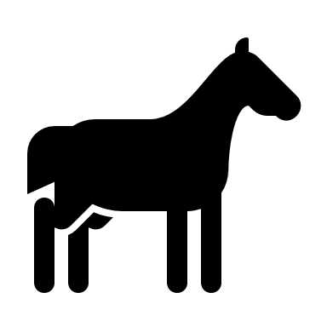 EQUINE FACILITY DAILY INSPECTION FORM

Inspection of the areas listed below should occur daily. Record any conditions or changes that could result in discharges to surface water and/or from the property under the control of the discharger on this sheet. Record the date, your initials, a check-mark beneath each column once the item is examined, and provide notes as needed, as well as the action taken to correct the issue or concern.
Reporting Year______________________
Facility Name_______________________________________
Facility Address______________________________________________
Date | Your Initials | Pumping equipment  (if applicable) | Waterlines | Outdoor animal wash racks | Corrals | Nearby Surface Water | Notes. Describe any manure containment conditions that could lead to discharges. If there are no such conditions, indicate, “None.” Note actions taken to correct any deficiencies. Attach additional notes as needed.
Note: Under the SF Bay CAF WDR, this record must be maintained for a period of 5 years after it is created and made available upon request during inspections.

Form to document non-stormwater discharges.
If enrolled in the San Francisco Bay CAF WDR, all adverse conditions, including discharges that are a threat to human health or the environment must be reported to the Water Board within 24 hours, and corrective action taken as soon as possible.

For every event of a discharge from your facility not comprised of clean water, one of these data sheets must be filled out and included in the annual report.
Date: _________________Time:____________________Observer:____________________
Facility name:______________________________
Description of discharge event:___________________________________________________
_____________________________________________________________________________
__________________________________________________________________________________________________________________________________________________________

Approximate amount of liquid or solid discharged (if known):________________________

Actions Required (note N/A if no action required):

Drawing and Observations:

