SOCIAL EQUITY
The Napa Green Certified Land (NGCL) program is focused on environmental stewardship, business sustainability and longevity, and social equity. Managing vineyard properties to maximize biodiversity, worker, and watershed health provides environmental and social benefits extending well beyond the property boundaries.

Human Resources and Workforce Assessment
This section focuses on ensuring that your operation is in compliance with human resources and workforce regulatory requirements, and implementing best management practices that go beyond compliance.

- Do you have employees? Yes | No
(If yes, complete sections below. If no, continue to Neighbors & Community)

Compliance:

- Do you have a process to regularly review and ensure compliance with state and federal labor requirements for human resource practices?
- If you work with a labor contractor have you ensured that they meet state license requirements?
- Do you have an employee safety training program in compliance with federal, state, and local law?
- Do you have an Injury and Illness Prevention Program?
- Do you have a Heat Illness Prevention Plan?

Program Requirements:

- Written Human Resources Plan (Required if you have 5 or more employees) with company mission, vision; staffing and recruiting; training and development; management; compensation and benefits.
Verification: Provide Plan

- Employee Orientation and Handbook - Orientation includes review of Handbook, overview and/or tour of company operations, culture, and sustainability policies and practices (should be included in the Handbook).
Verification: Provide Handbook

- Performance Evaluations (Formalized performance evaluations and written complaint process).
Verification: Provide blank evaluation

- Continuing Education, Training and Development (Regularly share training and continuing education opportunities, including training that covers sustainable practices, and encourage attendance, covering costs if applicable).
Verification: Share staff newsletter/email

- Alternative Transportation: Inform staff regularly (minimum quarterly) of alternative transportation incentives and opportunities (e.g. Bay Area Commuter Benefits Program; Napa Commute Challenge (Apr-June); custom incentives) and encourage them to use alternative transportation.

- Sustainability Management: Staff is assigned to manage implementation of the Vineyard Plan and maintain Napa Green Land certification; there are management planning meetings; and a process to get new employees informed and engaged.
Verification: Share staff name(s) and contact

- Bilingual Resources: If English isn’t required and there are staff whose first language is Spanish all resources are provided in English and Spanish.
Verification: Share Handbook or other resource in Spanish

Additional BMPs:

- Worker Safety & Training: Offer quarterly/bi-monthly training and safety meetings, document attendance, track and share safety statistics.
YES | NO

- Safety Rewards Program: Program to recognize and reward safe job performance.
YES | NO

YES | NO

- Worker Salaries and Benefits: Offer (indicate those that apply):

- All workers competitive salaries for your region
- Medical insurance
- Family support services
- Retirement benefits
- Bonuses and rewards

Additional detail:

- Promoting Sustainability in the Workplace - Staff is informed at least quarterly about environmental management practices and solicit input and suggestions from employees for continual improvement.
YES | NO

- Industry Knowledge and Participation - Managers subscribe to trade journals/publications and attend one or more local, regional, statewide, or national industry meetings annually.
YES | NO

- Compensation Benchmarking - Participate in an annual salary survey (e.g. Wine Business Monthly, CAWG) and benchmark compensation against regional average.
YES | NO

Resources:
- Napa Valley Vintners’ Community Investment
- Commitment to Farmworkers
- Napa Valley Vintners’ Action Plan for Affordable Housing
- Napa Valley Farmworker Foundation
- Napa County Farmworker Housing Centers
- Napa Valley Grapegrowers Wages & Benefits survey

NEIGHBORS AND COMMUNITY ASSESSMENT
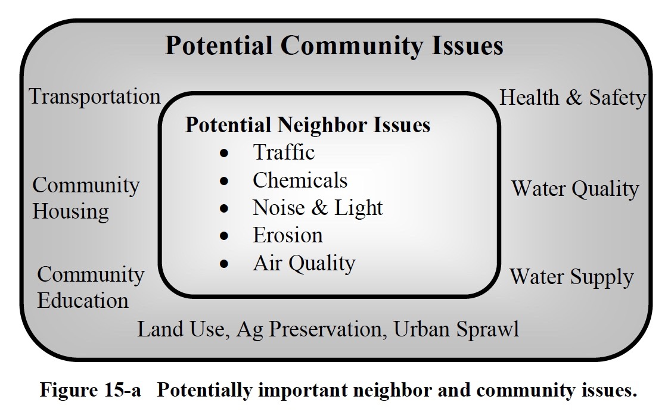
The Napa Valley Vintners and Grapegrowers and their members are constantly seeking new opportunities to invest in the community. The Napa Green Land program is an investment in the long-term preservation of this unique landscape. It can be a tool to help engage with neighbors and address any concerns. In addition to maintaining positive relationships with your neighbors and the community be sure they are aware of your Napa Green Land certification and efforts to reduce erosion and runoff, preserve and restore habitat, sequester carbon, conserve and recharge groundwater, and other sustainable land management practices.
(Source: California Sustainable Winegrowing Alliance, California Code of Sustainable Winegrowing Workbook, Ch. 15 Neighbors and Community)

Program Requirements:

- Contact Information - Neighbors who may be affected by operation have access to contact information for appropriate staff.

- Neighbor Notification - Notify neighbors about operations that might affect them.
Verification: Share example notification

- Feedback Procedures - Have a process for receiving, considering, and addressing neighbor/community feedback, questions, and concerns.
Verification: Share process

- Light, Noise, and Traffic - Consider ways light, noise, and traffic from operations may impact neighbors and make efforts to mitigate these impacts.
Verification: Share examples of mitigation

- Sustainability Communication - Communicate with neighbors about Napa Green Land certification and other sustainability practices through opportunities such as Afternoon in the Vineyards, website, tours, mailings, etc.
Verification: Share communications example

- Community Involvement - Participate in neighbor and community forums about issues of concern.
Verification: List forums attended

Additional BMPs:

- Participate in advisory or volunteer groups or form industry collaborations/partnerships to work on (indicate those that apply):

- Traffic and enhancing alternative transportation opportunities
- Affordable worker housing
- Riparian and other habitat restoration projects
- Water monitoring and conservation
- Sustainable land use planning
- Community Health
- Enhancing educational opportunities

Additional detail:

Worker Training - Conduct worker trainings regarding neighbor and community communications.
YES | NO

Resources:
- Afternoon in the Vineyard - Spotlights only Napa Green Certified Land members.
- NapaGreen.org
- Napa Valley Vintners’ Action Plan to address community concerns about Winery Compliance & Development, Transportation, Stewardship & Conservation
- Our Napa Valley
- Napa County Adopt-A-School Program

